Rapport d’activité : Semaine de la Francophonie au Brunei
12 au 20 mars 2016
Bandar Seri Begawan

La semaine de la francophonie au Brunei s’est tenue du 12 au 20 mars 2016. De nombreux événements, organisés par l’Alliance Française et avec l’appui de l’Ambassade de France, se sont déroulés tout au long de la semaine afin de promouvoir la culture et la langue française au Brunei. Le Jerudong Park, le Jubilee Park et le Royal Wharf Waterfront ont été trois endroits clés choisis pour l’organisation des événements (concert, exposition photo et audio « dis-moi dix mots », dîner en plein air et projection de films francophones lors du festival ciné-cité), l’Alliance Française ayant également eu le privilège d’accueillir une démonstration de cuisine dans ses locaux. La Semaine de la Francophonie a connu un véritable succès en rassemblant plus de 5500 personnes ainsi que de nombreux entrepreneurs locaux.
Grâce au support de l’Ambassade de France et du Ministre des Ressources naturelles et du Tourisme, Dato Paduka Hj Ali Hj Apong la Semaine de la Francophonie est devenu un événement grandiose au Brunei. Suite à ces soutiens, les événements qui se sont déroulés tout au long de la semaine ont connu un succès incontestable et ont pris une dimension inédite pour une Semaine de la Francophonie à Brunei. La participation des autres corps diplomatiques : le Haut-Commissaire du Canada, l’Ambassade de Suisse, l’Ambassade du Laos et l’Ambassade du Vietnam a permis de souligner la particularité de la Francophonie dans le monde. Enfin, la réussite de cette semaine repose également sur la coopération de l’organisation locale partenaire « The Collective » et des nombreux sponsors ayant pris part aux divers événements organisés : Air France, Cityneon Brunei, Baiduri Bank, Radisson Hotel Brunei, Starlodge Progresif, Image Inx, Misha Studios et IS Industrie Brunei. La Francophonie au Brunei a été realisee dans une dynamique du « faire ensemble pour servir à tous »

Programme de la Semaine de la Francophonie au Brunei

La Semaine de la Francophonie s’est déroulée autour des événements suivants :
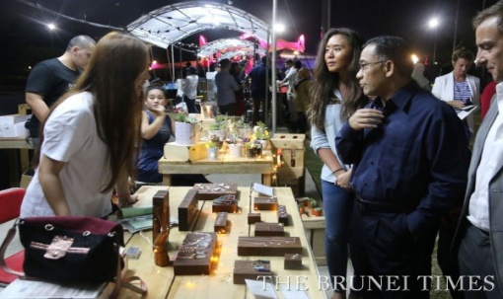
Le samedi 12 mars, Open air Cinema : Le film suisse « Win Win », réalisé par Claudio Tonetti, dans lequel un maire suisse prend la décision d’organiser les demi-finales de l’élection de Miss Chine dans son village. Au-delà d’un simple film francophone, le sujet a permis de poser un cadre solide pour cette semaine de la Francophonie au Brunei : la découverte d’une autre culture, la mise en avant d’une diversité culturelle propre à la francophonie mais également au Brunei, et le rassemblement des cultures francophones et brunéiennes. Près de 800 personnes étaient présentes, issues de toutes origines, au Jubilee Park pour cette cérémonie d’ouverture.
Le ministre des ressources naturelles et du tourisme YB Dato Paduka Hj Ali Hj Apong visite l’un des stands présents lors de l’ouverture de la Semaine de la Francophonie

Le Ministre des Ressources naturelles et du Tourisme était présent pour lancer les festivités, accompagné de Mme Loan Forgeron, Ambassadrice de France au Brunei, de M. Thomas Kupfer, Ambassadeur Suisse (non-résident), de Mme Marina Laker, Haut-Commissaire du Canada au Brunei, du président du comité de l’Alliance Française à Brunei, Pg Dato Paduka Hj Idris ibnu Al-Marhum Pg Temenggong Pg Hj Mohammad, ainsi que des membres du gouvernement Brunéien (Ministry of Foreign Affairs and Trade et Ministry of Home Affairs). (cf. Brunei Times 13/03/2016, Week-long Showcase of French culture).
Enfin, la cérémonie d’ouverture a également lancé le début de l’exposition sur le thème « Dis-moi dix mots », réalisée par Cécile Castilla, une journaliste française présente au Brunei depuis quatre ans. Dans ce projet audio et photographique, Cécile Castilla a enregistré les réactions de plusieurs Brunéiens à l’écoute des dix mots choisis comme thème cette année pour la semaine de la francophonie (ristrette, poudrerie, tap-tap, fada, chafouin, lumerotte, champagné, dépanneur, dracher, vigousse). Dans ce projet, la diversité des cultures francophones se mêle à la diversité culturelle brunéienne. Les sujets interrogés sont issus d’origines variées (chinois, malais) et incarnent l’aspect multiculturel du pays (cf. Brunei Times 18/03/2016, Capturing Bruneian essence through French eyes).
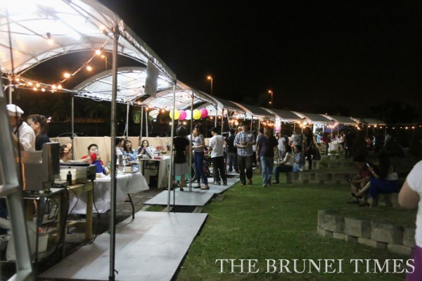
Le dimanche 13 mars, le Jubilee Park a accueilli la chanteuse suisse Noga, et le camerounais Patrick Bebey. L’événement a rassemblé plus de 1000 personnes. De nombreux entrepreneurs locaux étaient également présents pour commercialiser leurs produits, tournant autour du thème de la francophonie. Les divers événements lors de la semaine de la francophonie leur ont apporté une visibilité inédite (cf. Borneo Bulletin 16/03/2016 Francophonie Week continues with Ciné-Cité).

Le Lundi 14 mars : Open air Cinema : Le film français « Les Emotifs Anonymes » a été projeté au Jubilee Park le lundi 14 mars. Près de 130 personnes étaient au rendez-vous.
Cours de cuisine à l’Alliance Française le mercredi 17 mars. Photo : Mme Noriko Iki, Ambassadeur du Japon à Brunei, et Patrice Faivre, chef pâtissier.

Le mercredi 16 mars, une démonstration de cuisine française a été organisée dans les locaux de l’Alliance Française. Une quarantaine de personnes y ont pris part, afin notamment d’apprendre à réaliser des choux à la crème et des meringues grâce à l’aide du chef pâtissier Patrice Faivre. La démonstration a connu un franc succès auprès des participants, la cuisine étant l’un des moyens clés pour promouvoir l’échange culturel entre la France et le Brunei. L’ambassadeur du Japon au Brunei, Mme Noriko Iki, a notamment pris part à l’événement (cf. Brunei Times 17/03/2016, A glimpse of French cooking) et les participants ont pu avoir un aperçu de la prestation de la chanteuse canadienne Melanie Gall qui était présente ce soir-là.
Le vendredi 20 mars a été organisé un « Dîner en blanc » au Royal Wharf Waterfront. Le but de ce dîner était de promouvoir la francophonie par la cuisine, des chefs d’établissement réputés de Brunei (Radisson Hotel, the Energy Kitchen, Verve Café, et Vanilla Kitchen) ont relevé le défi de réaliser des plats typiques de pays francophones. La France, mais également le Canada et le Laos étaient à l’honneur dans les assiettes ce soir-là. Les chefs ont accompli leurs tâches et ont répondu présent en offrant un dîner créatif et gastronomique qui a ravi les convives, qui comptaient entre autres le ministre des ressources naturelles et du tourisme, le haut-commissaire canadien au Brunei, l’Ambassadeur d’Australie, l’Ambassadeur du Laos, l’Ambassadeur du Vietnam, le PDG de l’entreprise (et partenaire) Progresif, et le secrétaire du Ministry of Foreign Affairs and Trade (cf. Borneo Bulletin 20/03/2016, Francophonie Week 2016 continues to wow with Open Air Pop-Up Dinner).
Pour l’avant-dernier jour de la Semaine de la Francophonie, les participants ayant pris part aux événements au cours de la semaine ont eu l’honneur de se rendre à la résidence de Mme Loan Forgeron, Ambassadrice de France au Brunei, pour une réception dans laquelle la gastronomie française était à l’honneur (cf. Brunei Times 20/03/2016, Boosting ties over French cuisine). Plus de 80 personnes ont pris part à l’événement, qui comptait notamment comme invité d’honneur le Ministre des Ressources naturelles et du Tourisme, Dato Paduka Hj Ali Hj Apong, afin de le remercier pour son implication dans la Semaine de la Francophonie. Mme l’Ambassadrice Loan Forgeron ainsi que Dato Paduka Hj Ali Hj Apong se sont tous deux exprimés afin de saluer l’amitié franco-brunéienne et le succès de la Semaine de la Francophonie 2016 qui, par sa réussite, a contribué à renforcer les bases d’une coopération culturelle durable entre les deux pays.
Photo : Mme Loan Forgeron, Ambassadrice de France au Brunei Darussalam ; Pg Dato Paduka Hj Idris ibnu Al-Marhum Pg Temenggong Pg Hj Mohammad, Président du comité Alliance Française au Brunei ; Dato Paduka Hj Ali Hj Apong, ministre des Ressources naturelles et du Tourisme

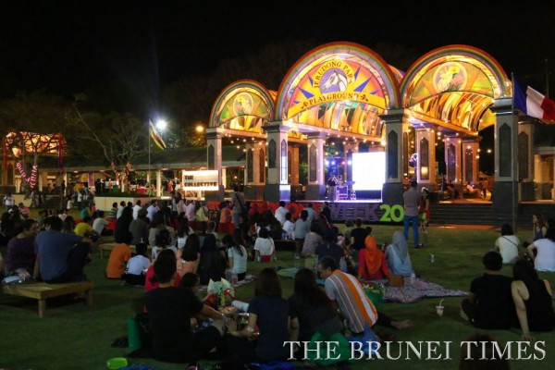
La Semaine de la Francophonie a pris fin le dimanche 20 mars au Jerudong Park lors d’une cérémonie de clôture qui a rassemblé 3500 personnes. Près de 80 élèves d’une école de musique locale ont interprété sur scène pendant l’après-midi des morceaux français et internationaux, pendant que de nombreux jeunes entrepreneurs locaux, membres de l’association « The Collective » ont profité de l’occasion pour commercialiser leurs produits, tournant autour du thème de la francophonie. Plusieurs interlocuteurs se sont exprimés : le président du comité Alliance Française de Brunei ; le consul suisse, Mme Fabienne Sylla-Pousse, directrice de l’Alliance Française à Brunei ; Mme Marina Laker, Haut-commissaire du Canada au Brunei ; Mme Loan Forgeron, Ambassadeur de France au Brunei ; puis Wardi Hj Mohammad Ali, secrétaire permanent au Ministère du Tourisme au Brunei. Un tirage au sort a eu lieu afin de permettre à un des participants de la Semaine de la Francophonie de gagner un aller-retour pour Paris offert par Air France.
La soirée s’est achevée par un concert de la chanteuse canadienne Mélanie Gall qui a interprété des titres classiques français et canadiens (Brunei Times 21/03/2016, Francophonie Week Concludes). Pour Wardi Hj Mohammad Ali, secrétaire permanent au Tourisme, cette semaine a été un véritable succès. Il a incité individus et groupes à organiser des événements similaires qui contribuent à promouvoir l’interculturalité et à attirer de nombreux visiteurs au Brunei.

La Semaine de la Francophonie et son impact sur le paysage culturel brunéien

La Semaine de la Francophonie a pour but de célébrer et de faire découvrir la diversité des cultures francophones dans le monde. L’enjeu est d’autant plus intéressant que le Brunei est également un pays multiculturel, où se côtoient Chinois, Malais, Philippins aux côtés d’autres nationalités. La diversité culturelle est l’un des piliers du pays. L’Alliance Française est parvenue cette année à créer un lien entre Brunéiens et francophones. Au soutien sans faille de l’Ambassade de France s’est ajoutée la participation des autres corps diplomatiques francophones du pays (Canada, Suisse, mais également Laos et Vietnam) et bien sûr celle du gouvernement de Brunei afin de donner à cette semaine une dimension majeure où l’échange culturel était la clé de la réussite
Les Brunéiens ont joué un rôle actif lors de cette Semaine de la Francophonie 2016, ne se limitant pas au simple rôle de spectateur (démonstration de cuisine interactive, entrepreneurs locaux commercialisant des produits autour du thème de la francophonie, etc). Ils ont pu obtenir un aperçu des activités organisées toute l’année par l’Alliance. La promotion des événements dans les journaux, mais également dans d’autres canaux de communication (affiches disposées dans la ville, présence importante sur les réseaux sociaux), a sans aucun doute contribué à faire connaître l’Alliance Française. La cérémonie de clôture et la participation d’Air France pour offrir un billet aller-retour pour Paris incarne bien l’esprit d’échange culturel de cette Semaine de la Francophonie 2016 au Brunei.
La Semaine de la Francophonie a été un succès sans précédent car elle a réunie toutes les couches sociales de la société bruniennes, les grandes entreprises et petites initiatives locales, le gouvernement et le corps diplomatique, en proposant de mettre en avant la diversité et le « vivre ensemble ».
Au-delà de la promotion de la diversité des cultures francophones au Brunei, un véritable échange culturel a pu avoir lieu entre Brunéiens et Francophones. L’Alliance Française a renforcé son rôle d’outil diplomatique culturel. Le soutien de l’Ambassade de France et la collaboration du gouvernement brunéien ont été des facteurs de succès indiscutables. La France est parvenue à apparaître en meneur des puissances francophones présentes au Brunei et en interlocuteur privilégié du gouvernement. Le renforcement des relations diplomatiques laisse à présager une évolution positive des échanges futurs entre les deux pays. Dorénavant, des événements culturels français de grande ampleur pourront être mis en place de manière régulière.
Prochain grand événement en perspective : Les 30 ans de l’Alliance Française au Brunei qui sera célèbre en partenariat avec le Ministère du Tourisme et de la Culture pour initier au Brunei une première édition de la nuit des musées. Le soutient de la Fondation Alliance Française pour la réalisation de ce projet serait vraiment très apprécie. (Date prévue : fin septembre)

ANNEXE
Brunei Times – 07/03/2016
http://www.bt.com.bn/happenings/2016/03/07/francophonie-week-starts-soon

Francophonie Week starts soon
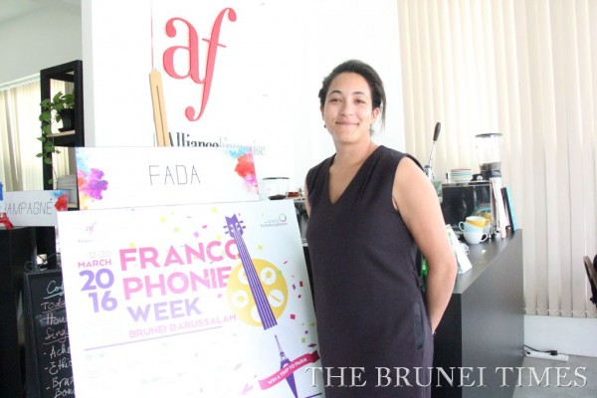
Director of Alliance Francaise de Brunei Fabienne Sylla-Pousse poses next to a poster promoting the upcoming Francophonie Week 2016. Picture: BT/ Adib Noor
ADIB NOOR
BANDAR SERI BEGAWAN
Monday, March 7, 2016
THE Francophonie Week 2016, which will take place from March 12 to March 20, promises a host of impressive activities for residents of Brunei to enjoy.
“This year’s Francophonie Week is packed with exciting events and activities, and it is also held In conjunction with Alliance Francaise de Brunei’s 30th anniversary of being in Brunei,” said the Director of Alliance Francaise de Brunei, Fabienne SyllaPousse, yesterday.
The one-week programme of events is aimed at promoting French culture and celebrate the cultural relations between France and Brunei. SyllaPousse said that with its strong global network, the organisation hopes to showcase the talented people in Brunei as well as promote the sultanate as wonderful tourist destination to the world.
The Francophonie Week will begin with the outdoor festival event titled “Cine-Cite” or “City-Cinema” at the Taman Jubilee or Jubilee Park, from 4.30pm to 10pm.
“This three-day festival like event will sure to be a memorable one as the part will be the grounds for the festival, and members of the public can enjoy a unique Franco themed open-air night market that showcases local creative businesses, with an outdoor cinema screening featuring a selection of French films selected by the Swiss embassy and Alliance Francaise,” she said.
The festival will also feature local acts, such as the Do It Good Records, Preservation Blues Jazz Hall Band and friends, as well as acoustic group FN DUO.
“Each day, the festival will feature a changing selection of local vendors, musicians and films, with a special Saturday night showcase by Swiss-born musician, Noga, along with her French counterpart Patrick Bebey, who are cultural envoys of the French Embassy and Alliance Francaise brought in especially for the event,” said the director.
Meanwhile, on March 16 at the Alliance Francaise de Brunei headquarters, local food lovers can experience the wonders of French food with various programmes and activities that allow you to get a taste of the many different flavours and cuisines of French regional countries from all around the world.
During the day, Chef Patrice will be holding a special demonstration, where participants will get the chance to learn the art of making selected French dessert, Choux A La Creme.
There will be a $10 entry fee and booking for seats are advised.
On the night of March 18 at 7pm, there will be an Open Air Pop-Up Dinner at the Waterfront in the capital. The dinner will also be a showcase of cuisines from various notable French regions. Tickets will be priced at $50 for a three-course meal.
And finally, on the night of March 20 at the Jerudong Park Colonnade, get ready to experience the Musique Symphony (Symphony Under The Stars).
Members of the public will get to experience an outdoors symphony concert under starlight, featuring the wonderful melodies of the students of Expressions Music as well as International Artist Melanie Gall as they perform against the stunning backdrop of of the grand carousel and Ferris Wheel.
The sure-to-be magical evening will be the finale of this year’s Francophonie Week.
To find out more about the events mentioned, and to book tickets and seats, visit www.progresif.com/home/francophonieweek2016.
The Brunei Times

Brunei Times – 13/03/2016
http://www.bt.com.bn/happenings/2016/03/13/week-long-showcase-french-culture

Week-long showcase of French culture
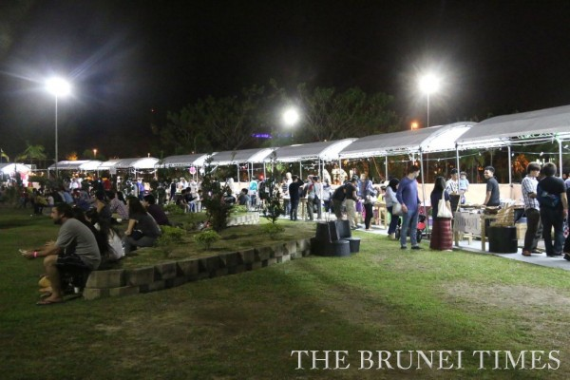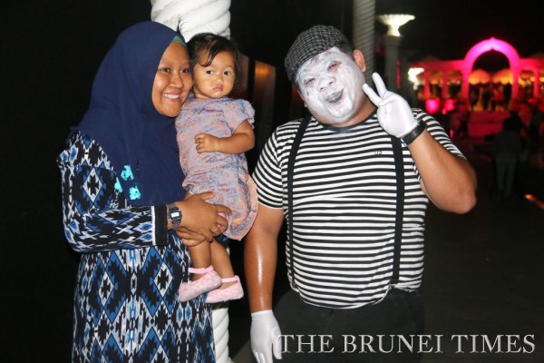
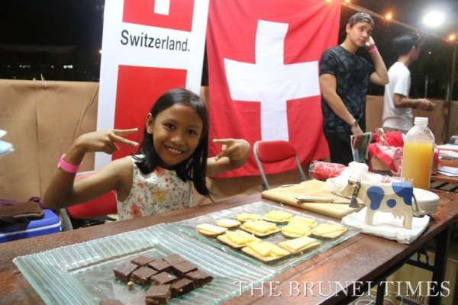Le Jubilee Park a accueilli de nombreux commerces locaux à l’occasion de l’ouverture de la semaine de la francophonie

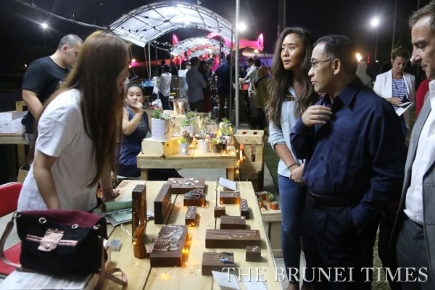
Le ministre des ressources naturelles et du tourisme YB Dato Paduka Hj Ali Hj Apong visite l’un des stands présents lors de la journée d’ouverture de la semaine de la francophonie

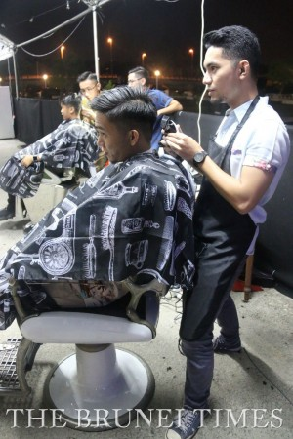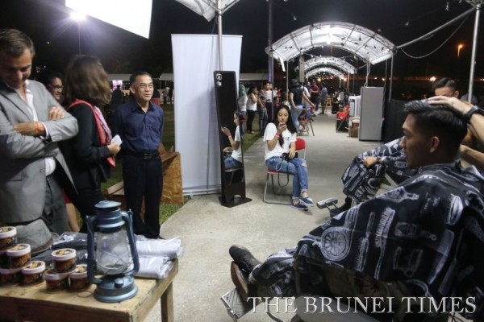
Un des exposants proposant des coupes de cheveux pour les hommes

- 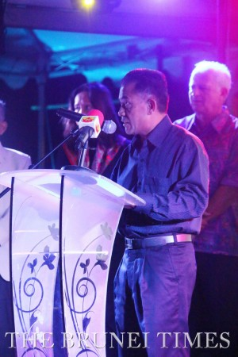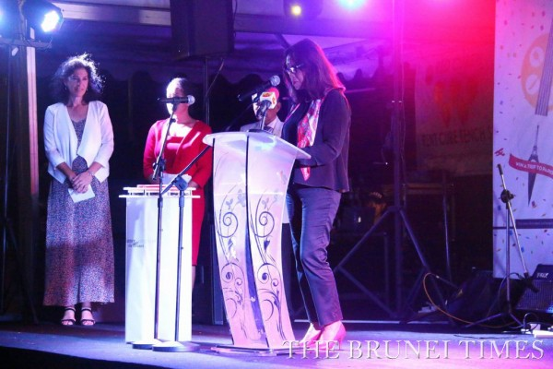

ANALISA AMU
BANDAR SERI BEGAWAN
Sunday, March 13, 2016
THE Alliance Francaise’s (AF) annual French cultural week dubbed ‘Francophonie Week 2016’ kicked off yesterday with an array of exciting events and activities.
Day one of the week-long programme saw crowds thronging Jubilee Park in the capital to get a glimpse of everything French through the outdoor festival titled ‘Cine-Cite’ or city-cinema.
This included the highlight, an open-air screening of a Swiss movie titled ‘Win Win’, a photography exhibition by a French journalist Cecile Cassou and well as French food and beverages.
The event, held daily until March 20 from 4.30pm until 10pm, also features a changing selection of local vendors, musicians and films. Entrance is charged $5 per person.
Present to launch the opening ceremony of the festival was the Minister of Primary Resources and Tourism Yang Berhormat Dato Paduka Hj Ali Hj Apong, who lauded the organisation’s effort in conducting the festival, which is held in conjunction with AF’s 30th anniversary in the nation.
Also in attendance were the French Ambassador to Brunei Loan Forgeron, the non-resident Swiss Ambassador, Thomas Kupfer, the Canadian High Commissioner, Marina Laker, and the President of the committee of AF Brunei, Pg Dato Paduka Hj Idris ibnu Al-Marhum Pg Temenggong Pg Hj Mohammad.
Aside from promoting French culture, ‘Francophonie Week 2016’ is aimed at celebrating the good relations between the nation and the sultanate.
Slated today at 8pm onwards, members of the public will get the opportunity to experience a symphony concert under stars by a Swiss duo Noga, who will be entertaining the audience with their classical, jazz African roots.
Throughout the week, the festival will feature the wonderful melodies of Expressions Music students as well as Canadian artist Melanie Gall, who will be performing against the stunning backdrop of the grand carousel and Ferris Wheel at the Jerudong Park Playground.
To find out more about the events and activities, and to book tickets and seats, visit www.progresif.com/home/francophonieweek2016.
The Brunei Times

Brunei Times – 17/03/2016
http://www.bt.com.bn/happenings/2016/03/17/glimpse-french-cooking

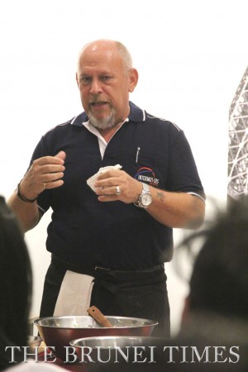
A glimpse of French cooking

Pastry chef Patrice Faivre invites an attendee to try out prepapring ‘Choux ala creme’ during the cooking demonstration held at AF de Brunei headquarters in Batu Bersurat. Picture: Courtesy of Fabienne Sylla-Pousse
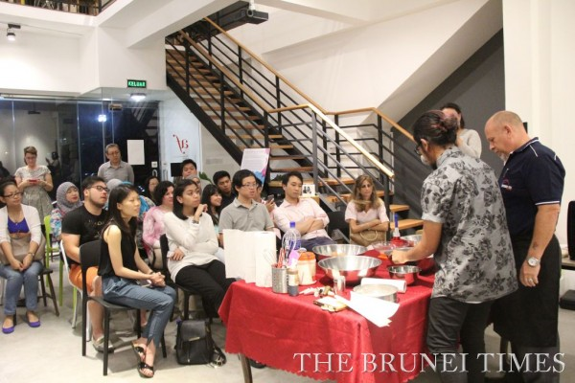
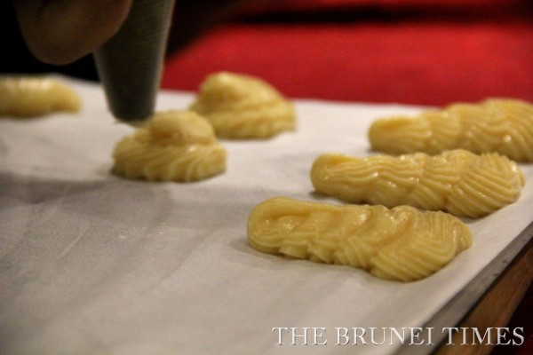
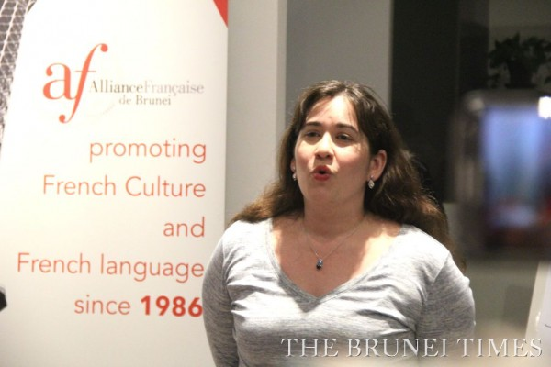

IKHWAN SALLEH
BANDAR SERI BEGAWAN
Thursday, March 17, 2016
THE aroma of freshly baked Choux ala crème yesterday tantalised the appetite of every attendee, who joined a cooking demonstration organised by Alliance Francaise (AF) de Brunei.
Held at the French cultural centre’s headquarters in Batu Bersurat, the special demonstration saw invited pastry chef Patrice Faivre conducting an interactive session, where participants had the opportunity to crack eggs open, beat dough and even taste the results.
The event, part of Francophonie Week 2016, was one of the initiatives planned by the non-government organisation for those who have the passion and love for baked goods, said Director Fabienne Sylla-Pousse.
She explained that a cooking show is conducted every month. “In January, we taught our members how to cook lemon tart and meringue, then in February, they learned how to cook pancakes,” she added. “It is one of our ways to promote and bridge two different cultures, Bruneian and French, in the most fun way as well as to appreciate talents (in culinary arts).”
Also joining the occasion were Japanese Ambassador to Brunei Darussalam Noriko Iki and Canadian artist Melanie Gall, who gave the audience a sneak peek of her performance.
To find out more about the events and activities, and to book tickets and seats, visit www.progresif.com/home/francophonieweek2016.
The Brunei Times

The Brunei Times – 18/03/2016
http://www.bt.com.bn/happenings/2016/03/18/capturing-bruneian-essence-through-french-eyes

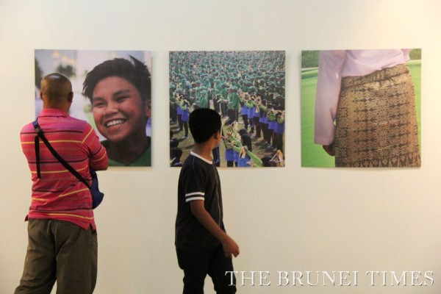
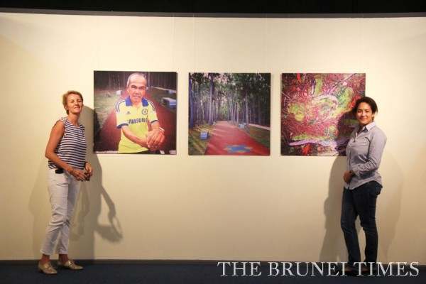
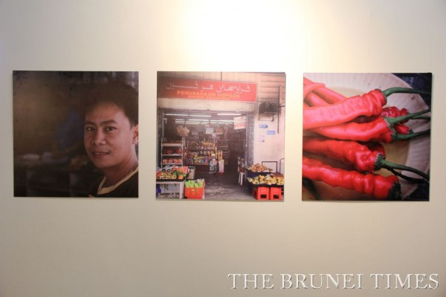
Capturing Bruneian essence through French eyes

French journalist Cecile Castilla (L) and Director of AF de Brunei Fabienne Sylla-Pousse (R) at one of the exhibits in triptych format. The exhibition is held at the Royal Wharf Art Gallery. Picture: BT/Ikhwan Salleh
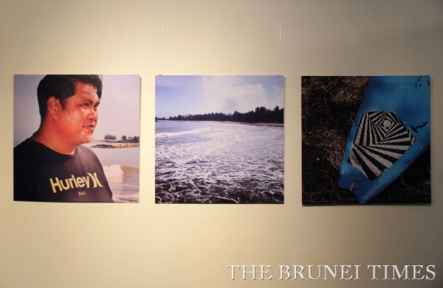
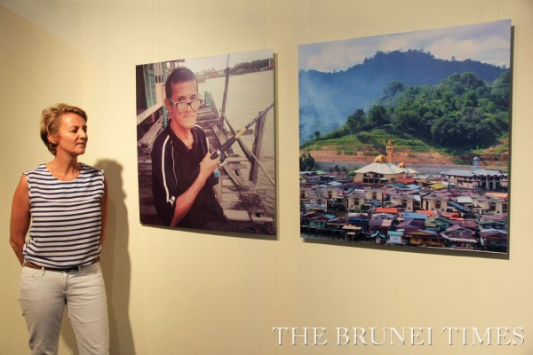

IKHWAN SALLEH
BANDAR SERI BEGAWAN
Friday, March 18, 2016
WITNESS the beauty of the sultanate in a photo -audio exhibition dubbed Dis Moi Dix Mots (Tell Me Ten Words) that is ongoing until Saturday, March 19 at the Royal Wharf Art Gallery.
The main idea – which is to capture Bruneians’ reactions towards 10 different French words – was developed by French journalist Cecile Castilla, who ventured through the streets of Brunei with her camera and recorder.
A total of 60 photos were assembled in triptych – a set of three panels – that consist of the subject, the general location and details of the venue along with short audio clips that animate the sequences.
Behind the recordings played in loop, the audience can perceive various sounds such as the chirping of insects at Tasek Lama, the bustling noise at Jerudong fish market and many other familiar locales. This creates both a visual and sound trip in the Kingdom of Unexpected Treasures.
At the launch of the exhibition yesterday, Castilla said her two-month effort aims to show the invisible cultural connection between Brunei and France. “Everyone reacts differently to the sound of a word,” she said.
Also supporting the movement was Director of Alliance Francaise (AF) de Brunei Fabienne Sylla-Pousse, who commented the displays show deep connection between the two countries, especially in respecting traditional values. “It shows diversity and happiness in the simplest form,” she added. For those who are interested, the art gallery is open from 9.30am to 11.30am and 2.30pm to 5pm today, and operates from 9am to 5pm on Saturday. As part of the Francophonie Week 2016 organised by the local French Cultural Centre, the exhibition will be making its appearance at the Jerudong Park Colonnade Garden on March 20.
The Brunei Times

Brunei Times - 20/03/2016
http://www.bt.com.bn/happenings/2016/03/20/boosting-ties-over-french-cuisine

Boosting ties over French cuisine
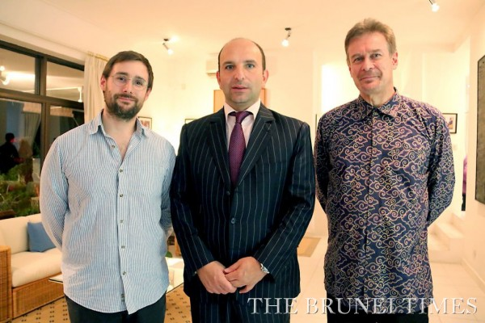
Baiduri Bank's CEO Pierre Imhof (R) with Director General of Prestige Communication Laurent Taieb (C) and French journalist Clement Airault (L). Picture: BT/Analisa Amu

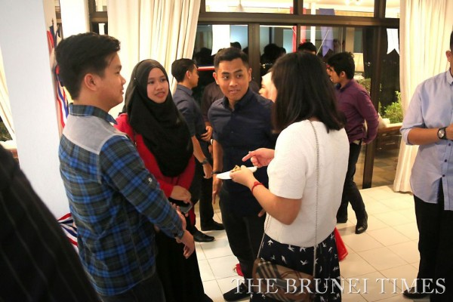
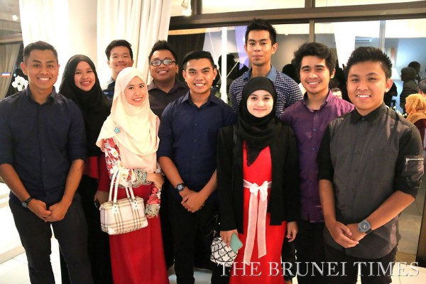

MPRT YB Dato Paduka Hj Ali Hj Apong and French Ambassador to Brunei Loan Forgeron (L) along with the President of the committee of Alliance Francaise de Brunei, Pg Dato Paduka Hj Idris ibnu Al-Marhum Pg Temenggong Pg Hj Mohammad (C), during the Good France Reception at the envoy’s residence in Kota Batu yesterday. Picture: BT/Analisa Amu

ANALISA AMU
BRUNEI – MUARA
Sunday, March 20, 2016
IT WAS a gastronomic gathering at the French Ambassador’s residence in Kota Batu last night as guests savoured an array of exquisite French delicacies in conjunction with Francophonie Week.
Over 80 guests – who included the guest of honour, Minister of Primary Resources and Tourism (MPRT) Yang Berhormat Dato Paduka Hj Ali Hj Apong – dined on food such as foie gras on toast, chicken a la parisienne and petits pots vanilla with four fruits with a view of the iconic Kampong Ayer to boot at the Good France Reception.
Prior to the start of the event, French Ambassador to Brunei Loan Forgeron expressed her appreciation to volunteers and participating bodies who were involved in making the Francophonie Week 2016 a success.
The get-together also saw the presence of other prominent figures such as Laos Ambassador to Brunei Amphay Kindavong and spouse, Myanmar Ambassador-designate to Brunei U Cho Htun Aung, Canadian High Commissioner Marina Laker and Baiduri Bank’s CEO Pierre Imhof, who had the opportunity to mingle with other guests.
The Brunei Times

Brunei Times 21/03/2016
http://www.bt.com.bn/happenings/2016/03/21/francophonie-week-concludes

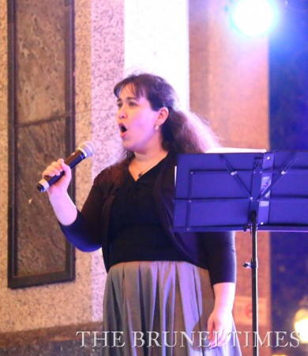
Francophonie Week concludes
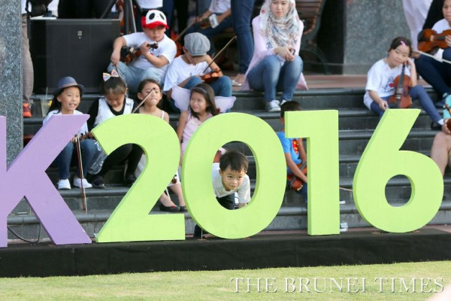

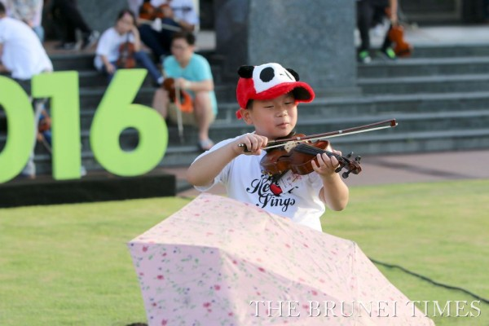

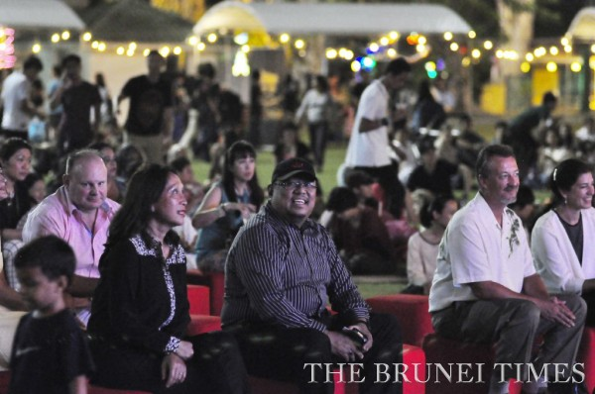
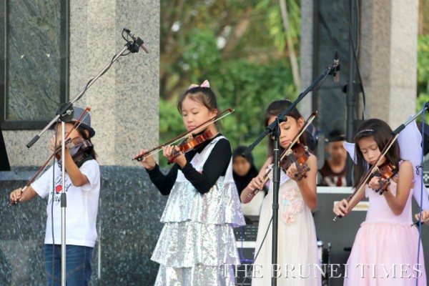

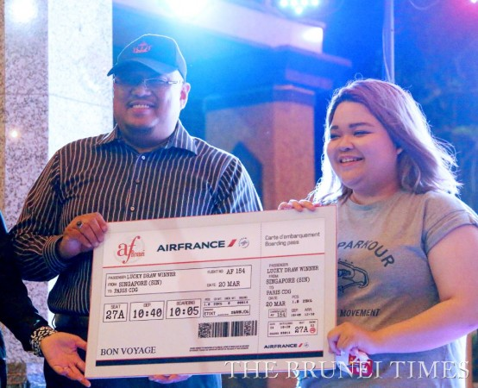

Deputy Permanent Secretary (Tourism) Wardi Hj Mohammad Ali (L) presenting a mock ticket to Paris to lucky draw winner Amal Nadzirah Salehen during the closing ceremony of the Francophonie Week at The Colonnade, Jerudong Park yesterday. Picture: BT/Khaliq Rozaiman

ANALISA AMU
BANDAR SERI BEGAWAN
Monday, March 21, 2016
THE Francophonie Week 2016 ended yesterday with musical performances at the beautiful Collonade of Jerudong Park Playground.
Present as the guest of honour was the Ministry of Primary Resources and Tourism’s Acting Permanent Secretary Wardi Hj Mohammad Ali. In his remarks, Wardi lauded the efforts made by the Alliance Francaise (AF) de Brunei, the French Embassy and its stakeholders on their success in organising the event.
“I am happy to know the various places of interest in Brunei Darussalam selected for the Francophonie Week have attracted a large turnout, such as the open air cinema at the Sultan Haji Hassanal Bolkiah Silver Jubilee Park, Art Gallery, and the dinner at the Royal Wharf waterfront, and lastly the closing ceremony at Jerudong Park,” he said.
He also encouraged more individuals and groups to organise similar events throughout the year, while promoting various tourist attractions in the country.
“We look forward to welcoming many more visitors to Brunei Darussalam,” Wardi added.
Also present during the closing ceremony was French Ambassador Loan Forgeron; the President of the committee of AF Brunei, Pg Dato Paduka Hj Idris ibnu al-Mahrum Pg Tememgong Pg Hj Mohammad; the honorary Swiss consul to Brunei Darussalam, Pg Izad Ryan Pg Laila Kanun Diraja Pg Hj Bahrin; and High Commissioner of Canada Marina Laker.
Prior to the performance from the Canadian artiste Melanie Gall, a lucky draw to win a trip to Paris was conducted in front of the audience. The prize was claimed by 19-year-old Amal Nadzirah Salehen.
The Brunei Times

Brunei Times – 22/03/2016
http://www.bt.com.bn/letters-editor/2016/03/22/culture-festivalsbreak-monotony-boost-business

Culture festivals break monotony, boost business
Tuesday, March 22, 2016
IN THE last week, there has been buzz of activity that has brought the capital to life all thanks to Francophonie Week which celebrates French culture.
The kick-off to the festivities was held at Taman Jubilee and saw a crowd of families and youth coming out for an afternoon and evening of wholesome fun.
As someone who has spent close to five years here, I have personally never seen so many people out and about and taking the time out to support local businesses and entrepreneurs at one of the local parks.
We hear so much about how the local people prefer to indulge in good food, music and atmospheres outside of the country but if this past week can attest to anything, it’s that is not entirely true.
I hope these kinds of events will continue to be held and supported by the relevant authorities because aside from boosting the economy in whatever small way possible, it breaks the bleak monotony that has been overcast on the community lately.
Glad,
Gadong

Borneo Bulletin – 08/03/2016
http://borneobulletin.com.bn/francophone-week-to-be-extravaganza-of-colours-cuisine-music-and-language/

Francophone Week to be extravaganza of colours, cuisine, music and language
Ishan Ibrahim
LOCAL Francophiles and lovers of almost anything French are in for a real festive treat as Alliance Française de Brunei has announced the entertainment extravaganza Francophone Week 2016 which will showcase the French language, culture and history at several landmarks in Brunei Darussalam.
Alliance Française Director Fabienne Sylla-Pousse said a programme of events will run from March 12-20 that will “be bigger” than previous Francophone events as Alliance Française de Brunei celebrates its 30th anniversary this year in Brunei.
The event also aims to fete the good cultural relations between France and Brunei. The week-long programme will showcase the capabilities of Brunei’s local talents in terms of creative industries, events and the arts, explained Sylla-Pousse.
The vast network of Alliance Française organisations around the world will thus help to showcase Brunei’s potential as a destination and its many talents.
French Ambassador to Brunei Darussalam Loan Forgeron and Canadian High Commissioner to Brunei Darussalam Marina B Laker were also present at the press event.
Loan Forgeron noted this upcoming celebration will be an excellent opportunity for Bruneians to savour an event that is celebrated in many countries around the world, with many activities centred on the French language, culture and history.

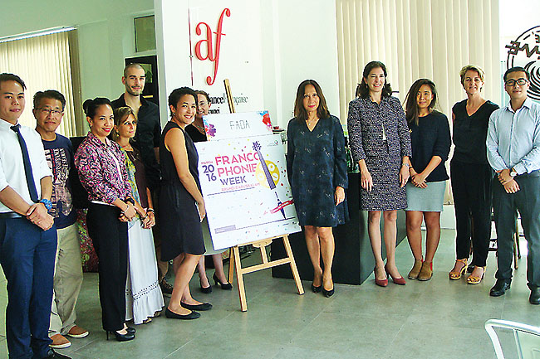
The French and Canadian emissaries with Director of Alliance Française and others. – ISHAN IBRAHIM
She said this is a good boost to local tourism. Marina B Laker agreed, noting that much like in her home country, Francophone Week is a major event celebrated in festive mood.
Local venues of the events include Jubilee Park, Jerudong Park and the Dermaga Diraja in the capital.
A three-day festival will transform the Jubilee Park into an outdoor cinema location over the opening weekend of Francophone week with the ‘Cine-Cite’ event.
It will apply an event concept new to Brunei, which combines a unique Franco-themed open air night market showcasing local creative businesses, with an outdoor cinema screening a selection of French films selected by the Swiss Consulate and Alliance Française, and performances by local musicians such as Do It Good Records Preservation Blues Jazz Hall Band and friends, FN DUO, Arif Zainudin, and Amal Murni.
Each day will see a change in local vendors, musicians and films, with a special Saturday night showcase by Swiss born musician, Noga, along with her French counterpart Patrick Bebey, who are cultural envoys of the French Embassy and Alliance Française brought in especially for the event.
There will also be art and photography exhibitions at the designated locations, as well as French cuisine activities that will give the locals a taste of the many different flavours and cuisines of French regional countries from all around the world.
The art exhibition will focus on the Truffle Moments Events created by a local business that has specialised in creating bespoke designer dessert tables for birthdays, weddings, corporate events and engagements since 2013. The Truffle Moments Events will be contributing an exclusive collaboration exhibition with Alliance Française for the ‘Dis moi dix mots’ (Tell Me 10 Words) project, merging art and dessert and featuring clay-sculpted French desserts. Each dessert will be styled in a way that hints at the meaning of the word.
The photography exhibition will feature French journalist Cecile Cassou as she interprets the annual Dis-Moi Dix Mots Francophone campaign with photography as their medium.
This year’s edition will explore the French spoken in the different French territories from all around the world.
A major highlight will be the Open Air Pop-Up Dinner at the waterfront that will see a special collaboration between three locally based chefs to create a unique menu that will showcase the cuisine of various French regions.
This is a signature event, an inaugural collaboration with Alliance Française to incorporate a Francophone theme. There will be local vendors selling diverse and assorted products at selected venues, a guaranteed fun event especially for families.
The event partner is the Collective Art Events with support from the Ministry of Primary Resources and Tourism, the Embassy of the Republic of France, the High Commission of Canada, the Switzerland Consulate, the Laotian Embassy, the Vietnam Embassy, Jerudong Park Playground, Baiduri Bank, Progresif Cellular Sdn Bhd, Cityneon Brunei, Image Inx, Airfrance, Radisson Hotel, StarLodge, Expressions Music, the Sequence Music Production and Industry Brunei.
To book tickets and view information and prices for each event, visit the website hosted by Progresif at http://www.progresif.com/home/francophonieweek2016/.
For more information, contact the Alliance Française at 2654245 or e-mail direction.afbrunei@gmail.com.

Borneo Bulletin – 16/03/2016
http://borneobulletin.com.bn/francophonie-week-continues-with-cine-cite/

Francophonie Week continues with Cine-Cité
Ishan Ibrahim
ALLIANCE Francaise’ Francophonie Week continues to stage more cultural events at Jubilee Park in the form of a Cine-Cité Outdoor Cinema, a Franco Market and some musical acts.
Recently, Swiss jazz artiste Noga and her partner, Patrick Bebey, were invited by the Swiss Embassy to perform at the Jubilee Park. The artistes presented songs from their latest album, ‘Laissez Partir’, which is an eclectic blend of jazz, world music and vocal improvisation.
Local musicians such as DIG Records, FN Duo and Amal Murni also performed jazz and acoustic covers of well-known songs.
In the meantime, young entrepreneurs were busy hawking their home-made creative designs and culinary delights at the park.
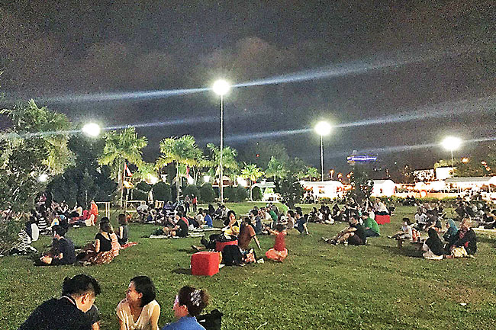
The scene at Jubilee Park. – PHOTOS: ISHAN IBRAHIM
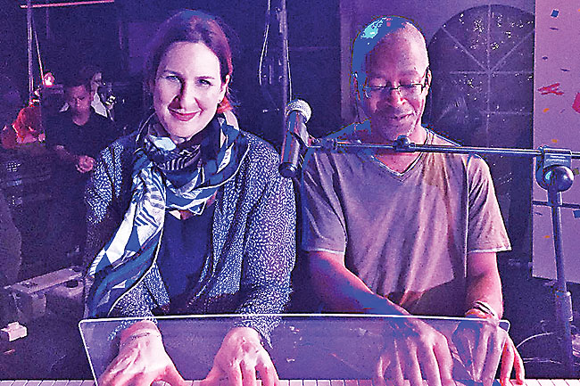
Swiss jazz artistes Noga and Patrick Bebey performing at the event
Yesterday, the Cine-Cité Outdoor Cinema presented the romantic comedy film, ‘Les Émotifs Anonymes’ (Romantics Anonymous), which tells the story of two people with a shared passion for chocolate.
For those with a taste for French films, Alliance Francaise holds a Cine Club every Tuesday at its headquarters in Batu Bersurat.
A special cooking demonstration will take place at the Alliance Francaise tomorrow by a local chef specialising in French cuisine.
An Open Air Pop-up French Dinner has also been scheduled for Friday, during which local chefs will be preparing a multi-course dinner at the Royal Wharf Waterfront.
For more information, contact 2654245.

Borneo Bulletin – 20/03/2016
http://borneobulletin.com.bn/francophonie-week-2016-continues-to-wow-diners-with-open-air-pop-up-dinner/

Francophonie Week 2016 continues to wow diners with Open Air Pop-Up Dinner
Fizah HAB
THE Francophonie Week 2016 continues with an Open Air Pop-Up French Dinner at the Dermaga Diraja in the capital.
Featuring showcase of cuisines from various notable French regions, the three course meal dinner attended by foreign state dignitaries, members of the diplomatic corps as well as French food enthusiasts enjoying their meal against the backdrop of Kampong Ayer at night.
“Tonight’s dinner is about promoting local chefs who are recreating French cuisine tonight, also combining influences from Vietnam and Laos. We chose to have the dinner at the waterfront as we would like to promote the night-life beauty of Kampong Ayer to the foreign guests and Bruneian to value the place,” said the Director of Alliance Francaise de Brunei, Fabienne Sylla-Pousse, yesterday.
The Francophonie Week will come to a close today with a special symphony concert under the starlight; the Musique Symphony (Symphony Under The Stars) at the Jerudong Park Colonnade.
Members of the public will get to experience an outdoor symphony concert.
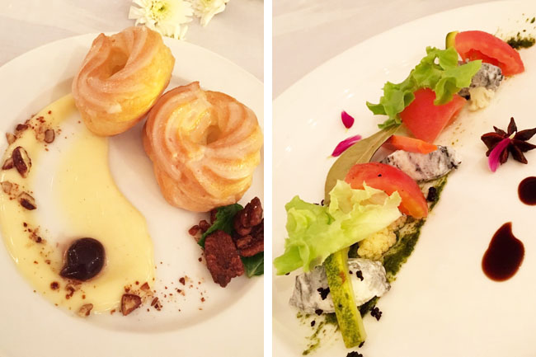
The Lemon Glazed French Cruller with Custard Creme, Brown Sugar and Cinnamon Toasted Nuts and Maple Liquid Spheres (left) Plum Tomato and Goat Cheese Salad with Homemade Pickles (right) as appetiser at the Pop-Up dinner. PHOTOS: FIZAH HAB

RTBnews – 13/03/2016
http://www.rtbnews.rtb.gov.bn/index.php?option=com_content&view=article&id=34459:launch-of-francophonie-week&catid=34:local&Itemid=66

Launch of Francophonie Week
Alliance Francaise de Brunei is taking measures to promote the French language and culture as well as to instil an awareness on the various differences found in regions that share the language and culture. Among the measures is the Francophonie Week which was launched at the Silver Jubilee Park in the capital.
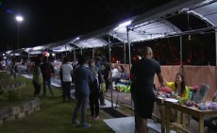
The event was launched by Yang Berhormat Dato Paduka Awang Haji Ali bin Haji Apong, the Minister of Primary Resources and Tourism and Her Excellency Loan Forgeron, Ambassador Extraordinary and Plenipotentiary of the Republic of France to Brunei Darussalam.
The Francophonie Week showcases and promotes products and services to the public. More than ten booths were provided at the event's 2-day expo that ended yesterday afternoon. The expo gave entrepreneurs the opportunity to further expand their business.

BruDirect – 21/03/2016
http://www.brudirect.com/0-national/national/national-local/item/47222-francophonie-week-concludes-with-musique-symphonique-concert

Francophonie Week concludes with musique symphonique concert
JERUDONG, BRUNEI-MUARA: The sounds of classical music resonated through the Jerudong Park Colonnade last evening during the Musique Symphonique concert which was the final event of the Alliance de France' Francophonie Week 2016.
The seven-day, festival has attracted many people to the French-themed events.
The final live music concert featured performances from The Expression Music, The Sequence Hot Band of Darussalam, and a guest artiste from Canada, Melanie Gall.
The event also saw the attendance of Deputy Permanent Secretary (Tourism) at the Ministry of Primary Resources and Tourism, Awang Wardi bin Haji Mohammad Ali, and French Ambassador to Brunei Darussalam, H. E. Loan Forgeron.
The lucky dip for the grand prize, a ticket to Paris, was also held. ©BRUDIRECT.COM

Seehua – 18/03/2016
Presse chinoise
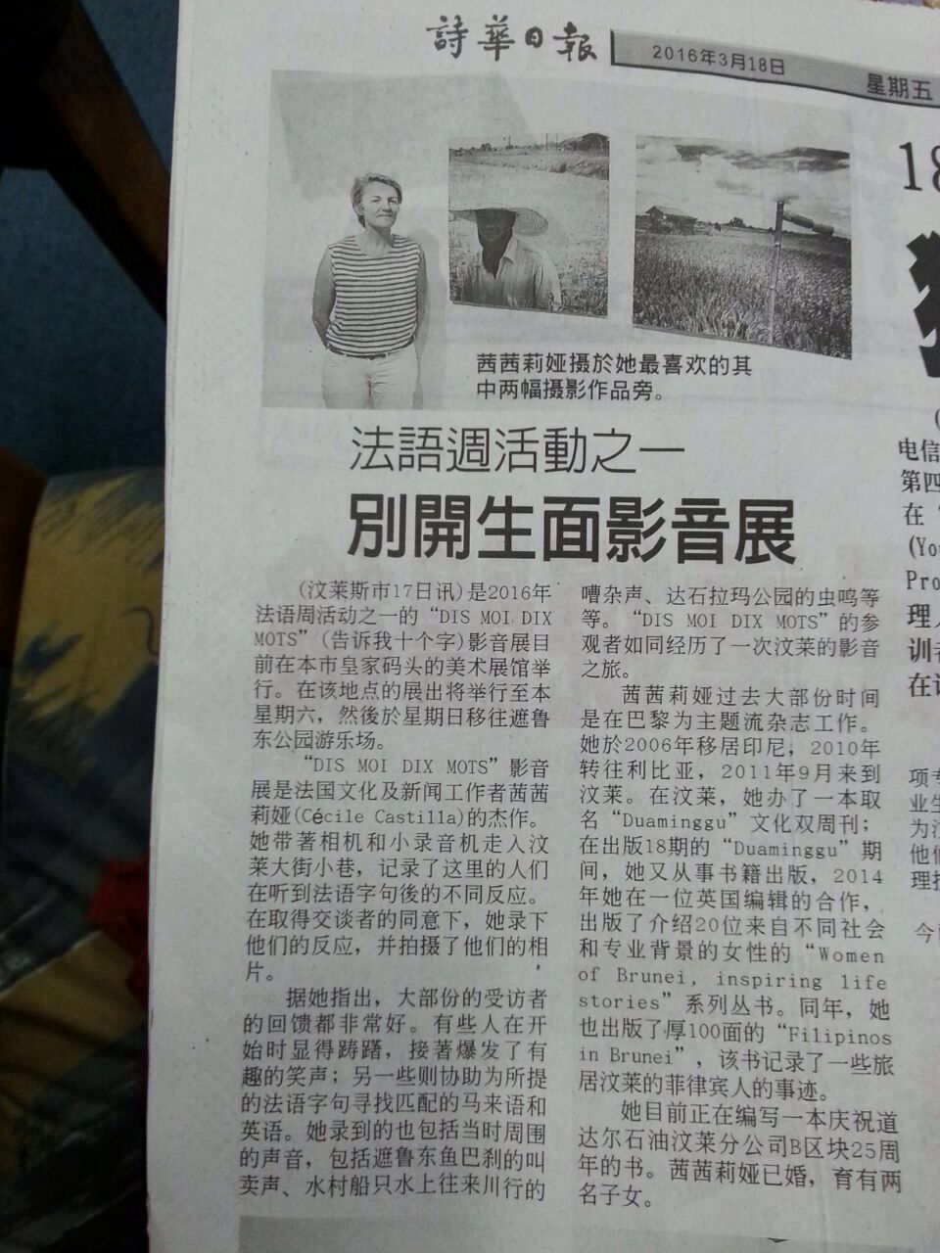

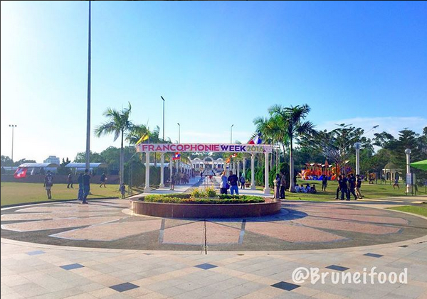
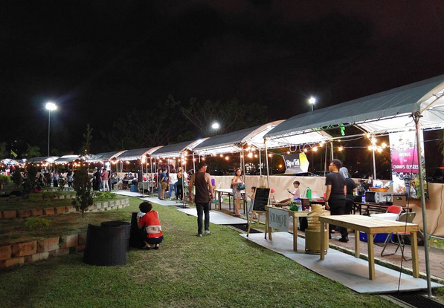
Photographies

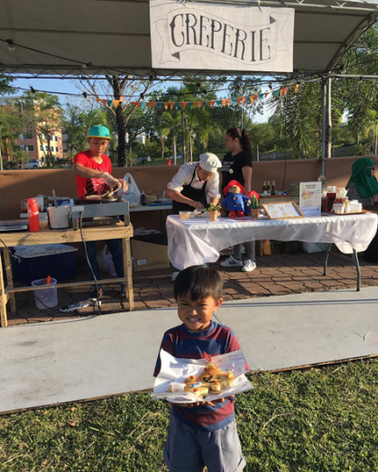
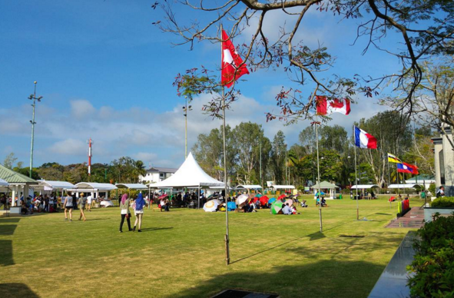

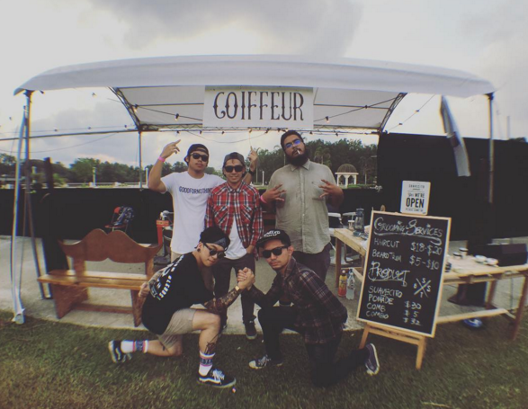

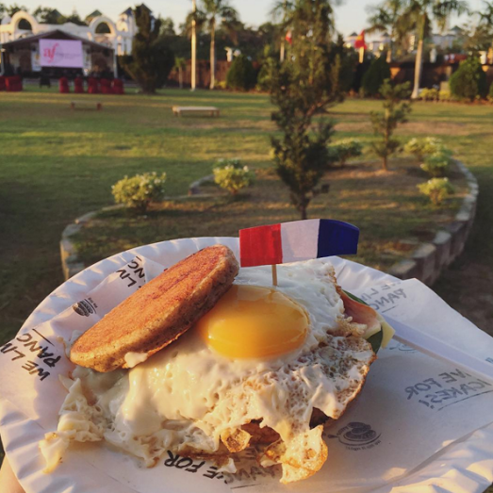

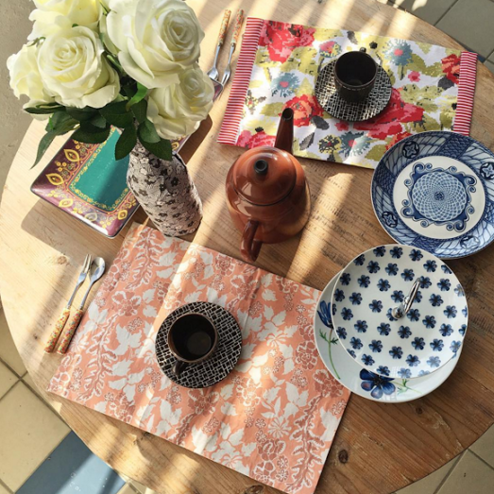

Jubilee Park 12/03/2016 et 13/03/2016

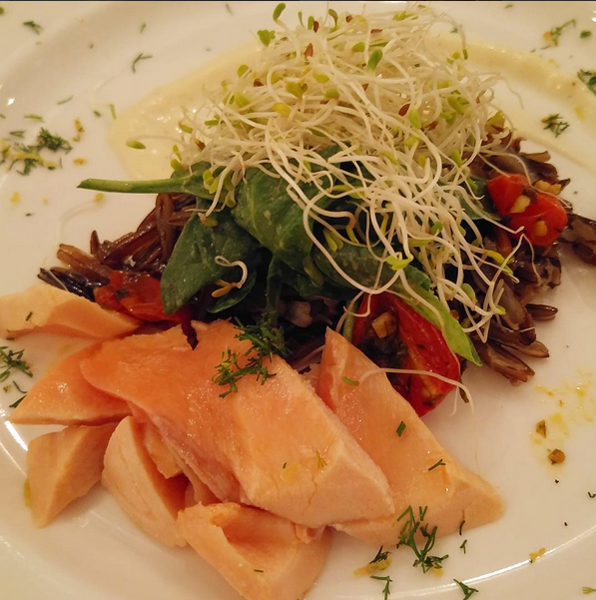
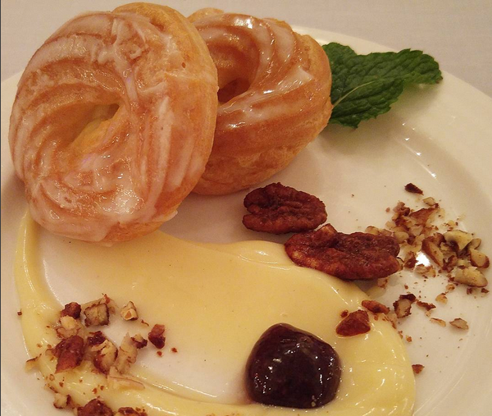
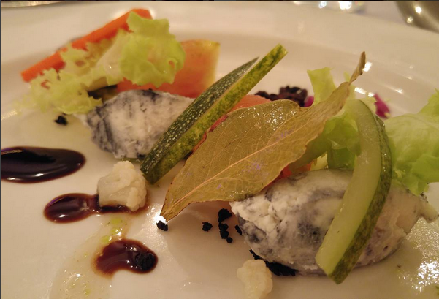
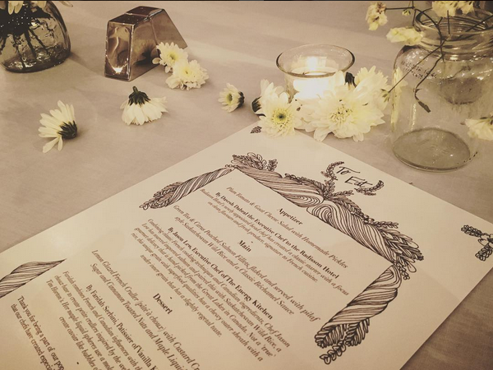
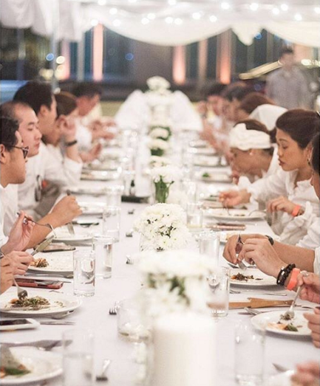

Pop-up dinner 18/03/2016
Royal Wharf Waterfront

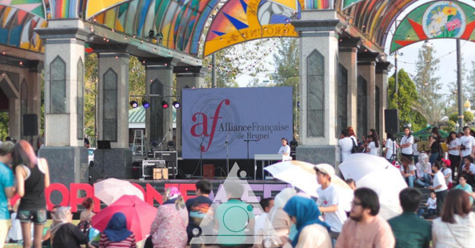
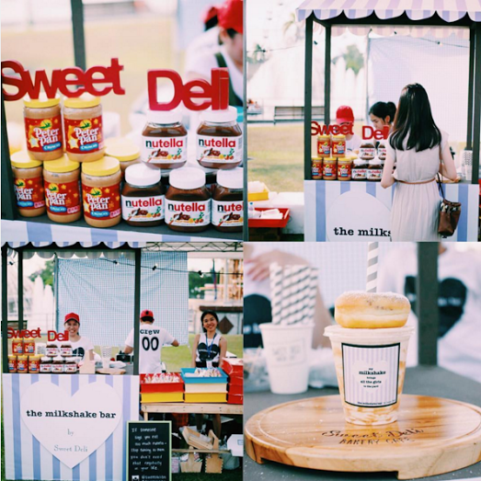
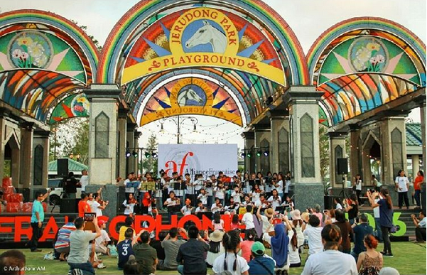
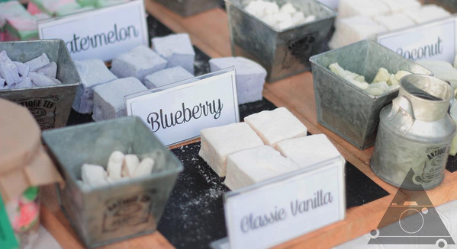
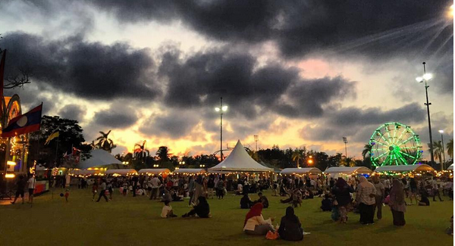
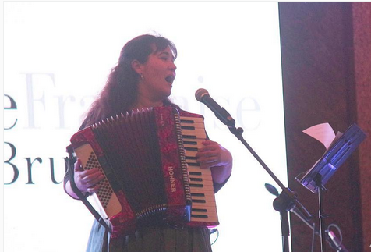
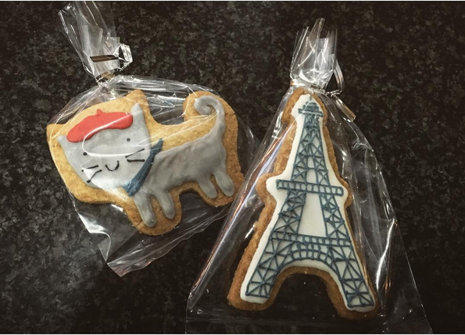
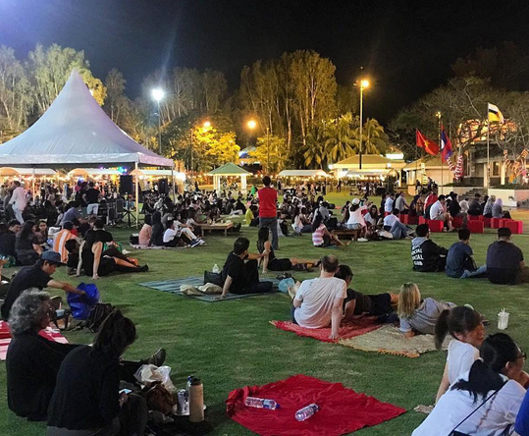
Jerudong Park 20/03/2016

